ASTEA Change Management Process

Flow Diagram
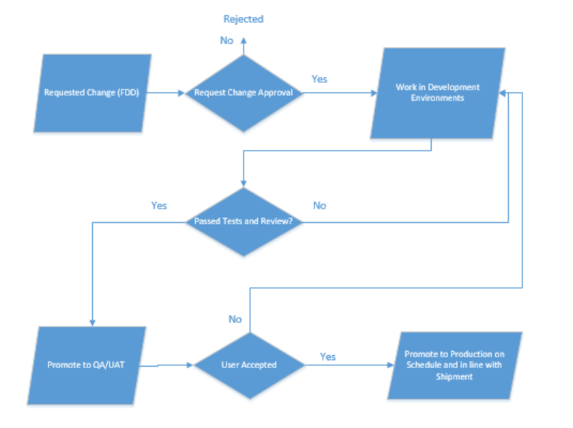

Change Request
- Written document that defines the changes to be made.
- Should include user test cases

Request Change Approval
- Request assigned to Technical lead for approval.

Work in Development Environments
- Unit Testing
- Peer Review

Passed tests and review
- Give a demo to the changes we have developed

Promote to QA/AUT
- Report changes deployment
- UI change deployment
- Escalation rule deployment

User Accepted
- Users have signed off on changes that are in QA

Promote to Production
- On a schedule and in line with shipment from ASTEA

Change List for End user example
https://custom.apigroupinc.com/sites/NSGTechDB/Lists/ASTEA%20Change%20Management/AllItems.aspx

